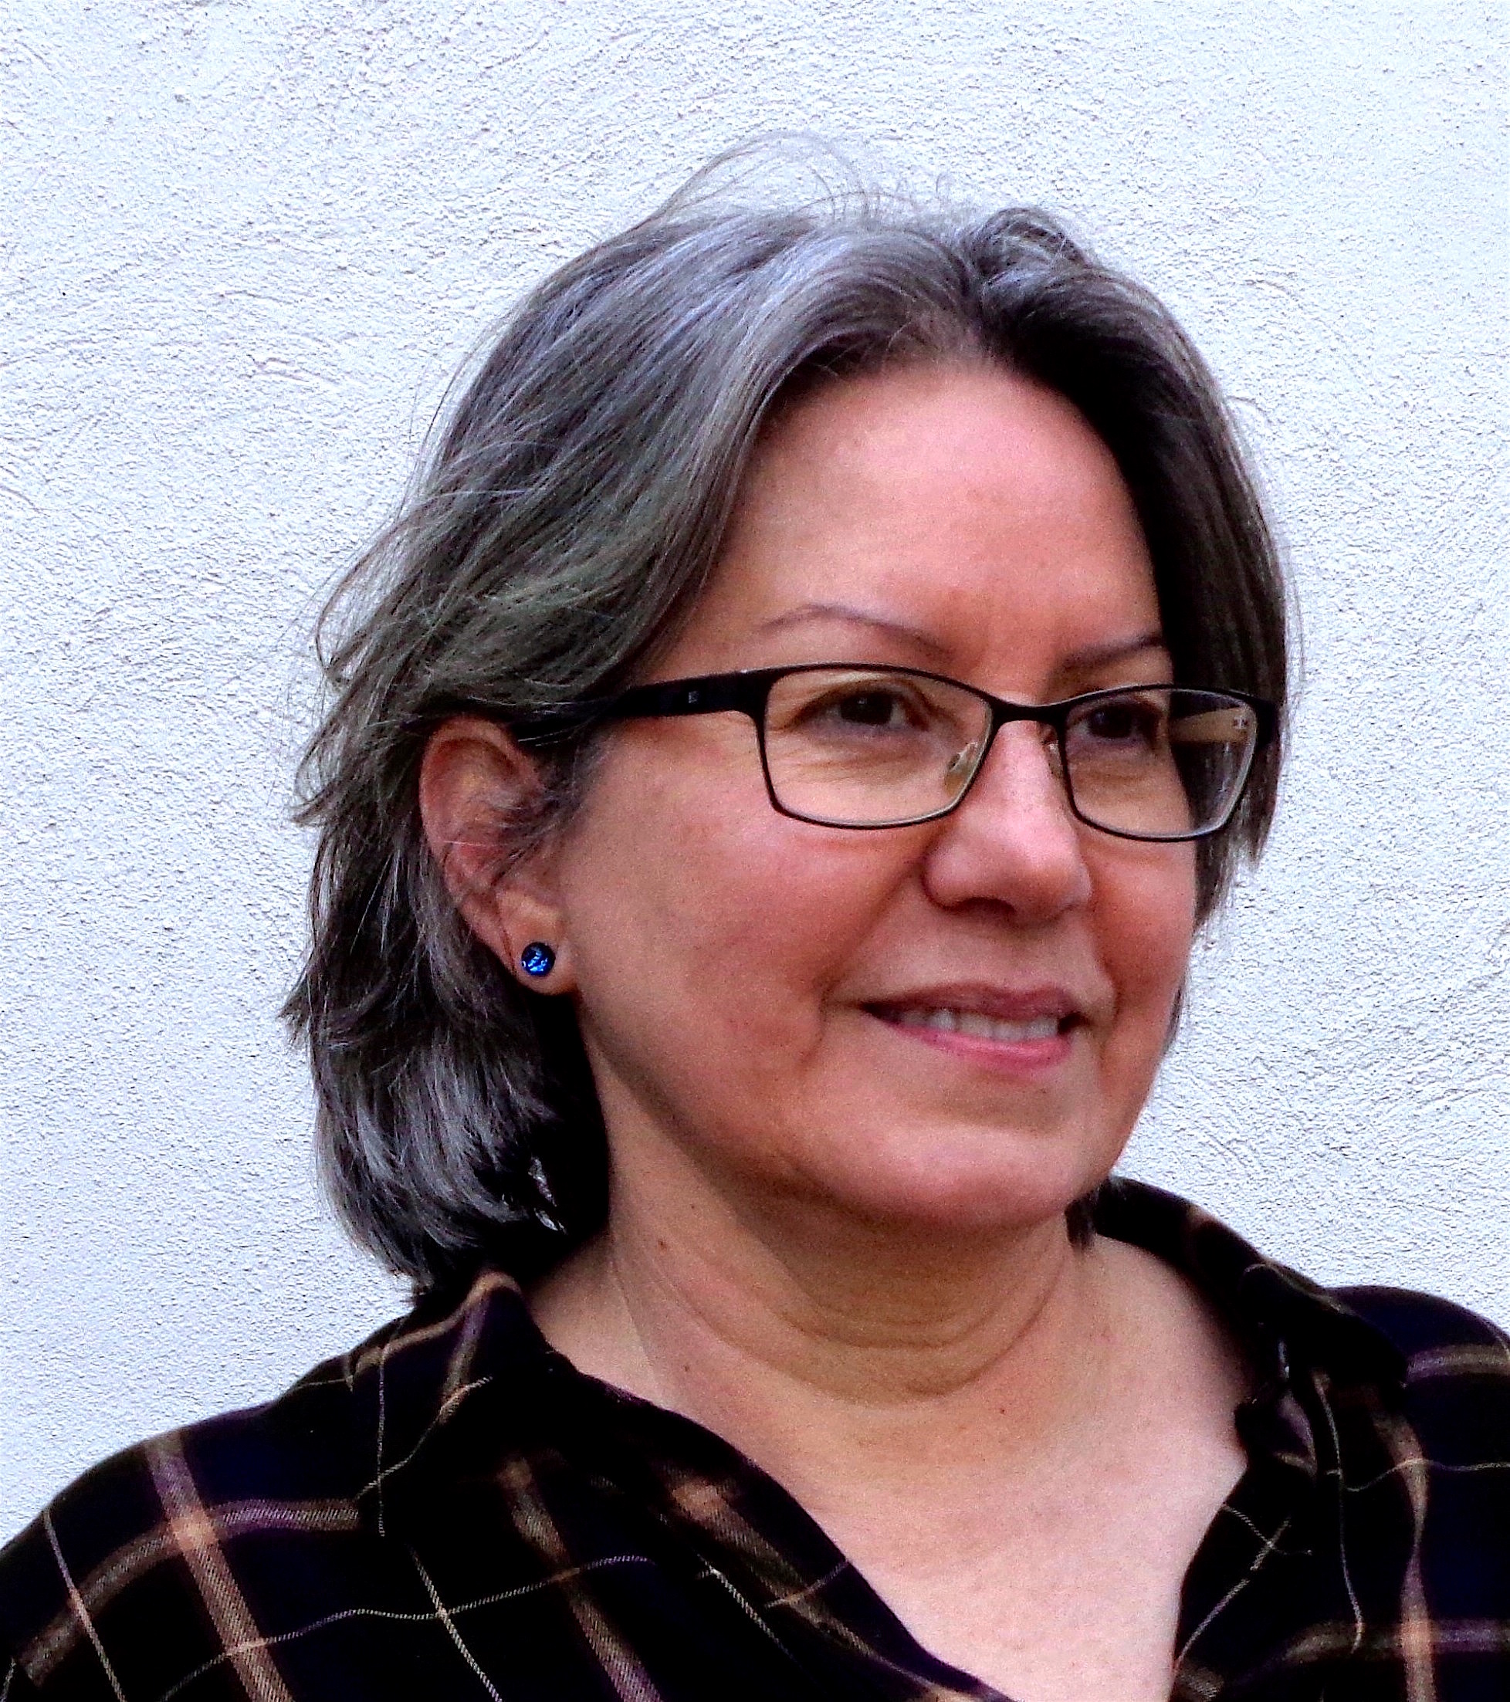
Norine Kevolic

Norine Kevolic is a long-time resident of New Hope, PA, born in Philadelphia and raised in Bucks County. Early on, her artist father imparted to her an openness to artistic expression in all its aspects. Norine has long enjoyed expressing herself by painting, drawing in silverpoint, and creating wood and bamboo relief sculpture.

She frequently sketches along the Delaware River and canal paths, and while hiking through the many parks of Bucks County.

“I think of my art art as a collaboration with Nature. I love meadows and sunsets,
water and moonlight, beach stones, shells and curious natural elements ~ but mostly,
absorbing the fleeting moments of possibility or memory that these things awaken.”

In the more than 30 years that she has exhibited throughout the Delaware Valley region, and in select online exhibitions, Norine has consistently received critical recognition and numerous awards for her work.

Some of the local venues where her work has been shown are: Phillips’ Mill; Stover Mill; Prallsville Mill; Philadelphia Sketch Club; Duke Gallery (Wallingford, PA); national juried Works in Wood and annual Sculpture shows at New Hope Arts; Trenton City Museum; Artists’ Gallery, Lambertville, NJ; and in select online venues that include Crafthaus; The Society of Metalpoint Artists; and American Bamboo Society Art Competitions.

She writes in depth about her art and inspiration at NorineKevolic.com and regularly posts silverpoint drawings with the Society of Metalpoint Artists on Facebook. Her art events and new works are shared on Facebook at NorineKevolicArt, and on Instagram.

