Leah Foley

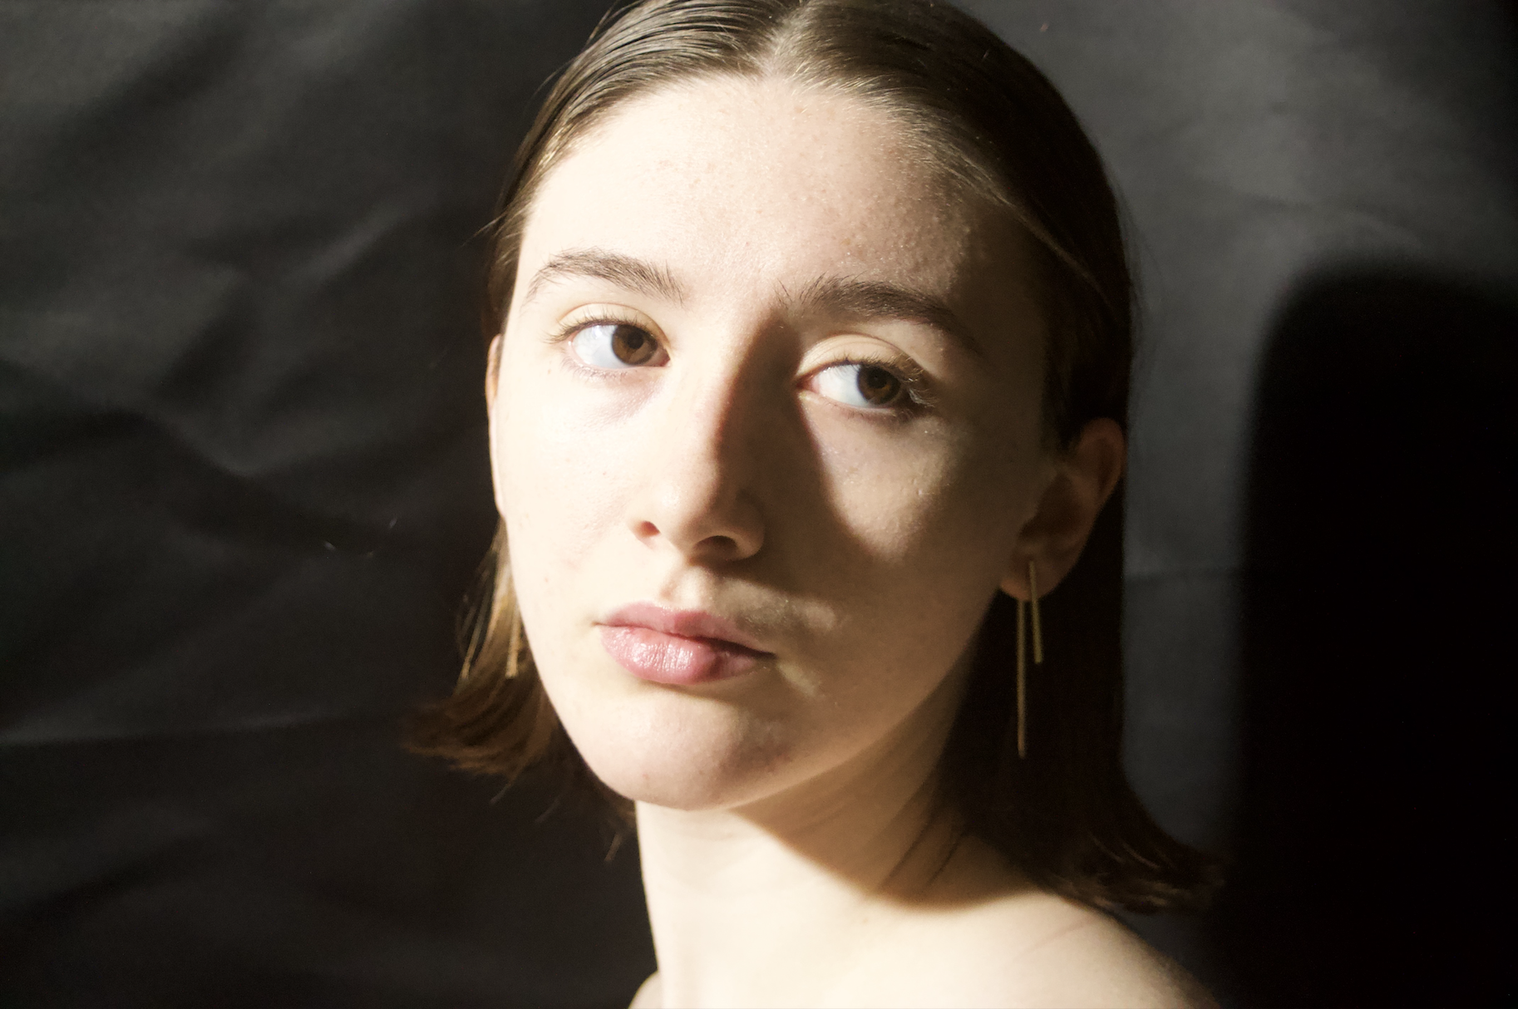

(b. 2001) From trading drawings of Pokémon characters for stickers in her bucks county elementary school, to winning a photography contest with an android phone, Leah Foley was born to be an artist. Just don’t call it a gift; her skill has been honed through years of patience and practice. Just ask any of her high school teachers. Yet the idea to pursue art as her profession did not strike until 2017, while developing her hobby for portraiture. Leah undertook a brief stint in a college art program, but knew quickly that her ambitions would benefit far more from traditional tutelage. In November of 2021, Leah began studying under acclaimed Bucks County master of Still Life oil painting, Frank Arcuri (whom she eagerly recommends as a teacher to any aspiring artists). From the start of their weekly sessions until July 2023, Leah learned and grew fond of her teacher’s “illusion of light” technique. Today, although still fond of portraiture, she spends most of her time finding the light in still lifes.